Customize Document Splitting

Over View:

SAP has delivered a set of pre-configured Document Splitting rules that should cater to most business scenarios. However, in many business scenarios, these rules may not meet the requirements of the business.

In this blog, I will explore the customisation of Document Splitting by configuring Extended Document Splitting – this configuration allows you to split line items that would not normally split based on SAP pre-configured rules.

Blogs on Document Splitting

In my series of blogs on document splitting, I intend to explain and elaborate the concepts behind Document Splitting and highlight using examples how document splitting can be achieved for various complex business processes. I use Profit Centre as a “scenario” to explain the functionalities; however all processes that apply to Profit Centre also apply to the other scenarios (Segment, Business Area).

Assumption for this blog

1.Overview of new GL Document Splitting Process

2.Architecture of SAP new GL

3.The Design driving the new GL Document Splitting process

4.SAP delivered pre-configuration for document splitting in SAP new GL

5.The semantics of SAP new GL document splitting process

Posting with pre-configured Document Splitting rules

We have seen that SAP has delivered pre-configured settings for Document Splitting. However, these settings may not suit all business processes for individual customers.

Below is a scenario of an expense payment made from Petty Cash. This document was posted using SAP pre-configured Document Splitting rules. The financial document has not split; the Profit Centre against Petty Cash is blank. (The document could generate an error message instead of posting to blank Profit Centre depending on SAP pre-configured rules).

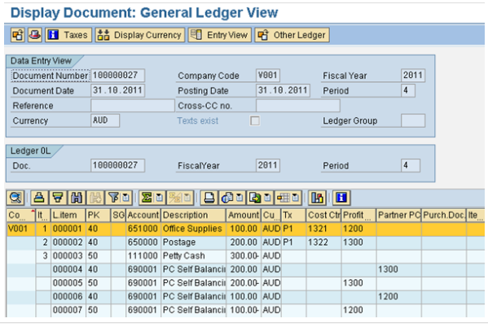

Document Type SA is mapped to Transaction 0000 and Variant 0001 (unspecified posting). This combination of Business Transaction and Business Transaction Variant is not well pre-configured.

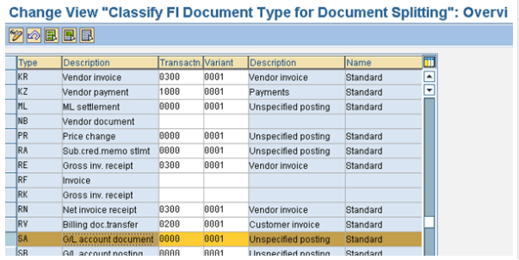

One option is to map Document Type SA to a different business transaction and business transaction variant.

However, the recommended approach is to create new Document Splitting rules to suit your business processes. You should not modify the SAP standard pre-configured Document Splitting rules. Instead, copy all standard Document Splitting rules under Document Splitting Method 0000000012 to a new set of rules under Document Splitting method Z000000012. Then proceed to modify the rules.

To change the assignment of Document Splitting method in the “Activate Document Splitting” configuration to point to Z000000012.

Steps to customize Document Splitting

Define Document Splitting Method

Define Document Splitting Rule

Assign Document Splitting Method

Define Business Transaction Variants (optional)

1.Define Document Splitting Method

As mentioned before, create a new Document Splitting Method Z000000012 as a copy from SAP standard Document Splitting Method 0000000012.

Configuration can be performed in IMG menu path

Financial Accounting (New) > General Ledger Accounting (New) > Business Transactions > Document Splitting > Extended Document Splitting > Define 1.Document Splitting Method

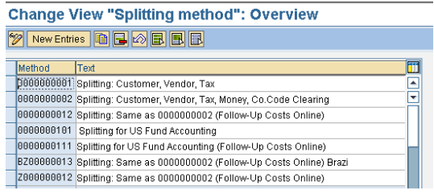

2.Define Document Splitting Rule

Document Splitting rule assigns Business Transaction and Business Transaction Variant to Document Splitting Method. In the scenario of Petty Cash expense, the Business Transaction is 0000 and the Business Transaction Variant is 0001. We will proceed to modify the splitting rule for this combination.

Configuration can be performed in IMG menu path

Financial Accounting (New) > General Ledger Accounting (New) > Business Transactions > Document Splitting > Extended Document Splitting > Define Document Splitting Rule

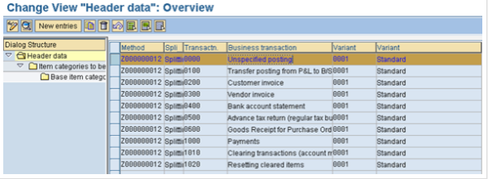

Add Item Category 20000 (Expense) as a “Base Item Category” used to split Item Category 0400 (Cash Account).

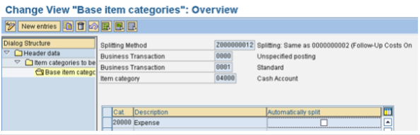

3.Assign Document Splitting Method

Assign the newly created Document Splitting Method Z000000012 to the activation of Document Splitting.

Configuration can be performed in IMG menu path

Financial Accounting (New) > General Ledger Accounting (New) > Business Transactions > Document Splitting > Extended Document Splitting > Assign Document Splitting MethodPosting with customised Document Splitting Rules

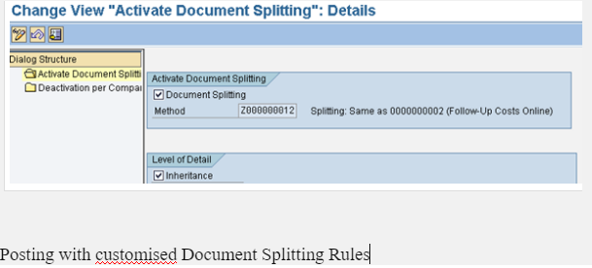

We can now post a similar Petty Cash expense transaction to test our customisation of Document Splitting rules. You will notice that the Petty Cash transaction is now split based on offsetting expense line items.

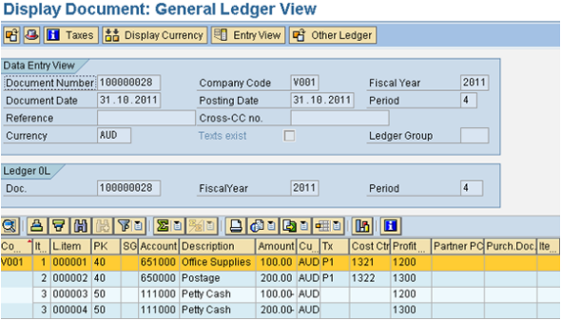

Conclusion

Pre-configured SAP Document Splitting Rules work for many business processes. However, it is not meant to be comprehensive. Customers should review their business processes and also review which processes post to Business Transaction 0000 and Business Transaction Variant 0001. These are the transactions that normally post without Profit Centre (or generate an error message for missing Profit Centre depending on configuration).

Generally, most customers prefer to post corporate Balance Sheet items (like Cash, Bank, Loans, Equity) to a default Profit Centre instead of splitting them across various Profit Centres. Only Vendors, Customers, Assets, Inventories are suitable to split across Profit Centres. This customisation is achieved by configuring “Constants” in the Document Splitting process. By configuring constants, you can post all lines items “missing” a Profit Centre assignment to a default Profit Centre. We will review the use of Constants in the Document Splitting process in the next blog.